Number of Calculation Fields
In this project DAX measures are used to analyze student performance, engagement, pass rates, and dropout behavior.
1.Total Students
2.Average Score
3.Average Clicks
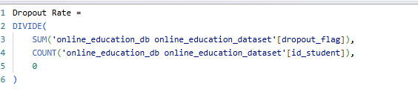
4.Dropout Rate
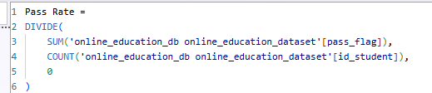
5.Pass Rate

"The Power BI dashboard implements interactive slicers and filters to provide self-service root-cause analysis without altering the underlying raw data architecture. By exposing filters for Gender, Region, Engagement Level, Performance Level, Risk Level, and Final Result, users can dynamically isolate specific cohorts within the 26,074 unique students.
For example, an educator can filter for students flagged as 'High Risk' who also fall into a 'Low' Engagement Level category. Power BI dynamically recalculates core performance metrics—such as the avg_score, studied_credits, and final categorical outcomes (final_result)—on the fly. This interactive slicing empowers stakeholders to move seamlessly from macro-level regional overviews down to hyper-targeted student risk clusters."

